

A Student

Graded Unit Project

**User’s Guide**

Contents

Patient Guide 9

**1.** **The Main Menu** 9

**2.** **The Patient Interface** 9

**3.** **The Confirmation Screen** 10

**4.** **The Attendance Confirmation Screen** 11

Doctor’s Guide 11

**1.** **Signing In** 11

**2.** **Doctor’s Home Screen** 12

**3.** **Reviewing the Timetable** 14

4. **Checking Patient Arrivals** 15

Administrator’s Guide 16

1. **Signing In** 16

**2.** **The Administrators Home Screen** 17

**3.** **Adding an Appointment** 18

**4.** **Editing an Appointment** 19

**5.** **Adding a Patient** 20

**6.** **Editing a Patient** 21

**7.** **Adding a Doctor** 22

**8.** **Editing a Doctor** 23

**9.** **Editing the Timetable of a Doctor** 24

# Patient Guide

1. **The Main Menu**

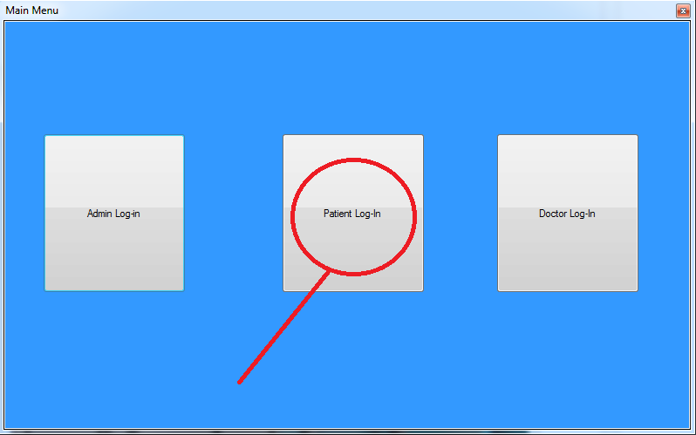

As a patient, we are going to want to use the Patient Log-In button, which is located in the middle of the screen, as circled above.

1. **The Patient Interface**

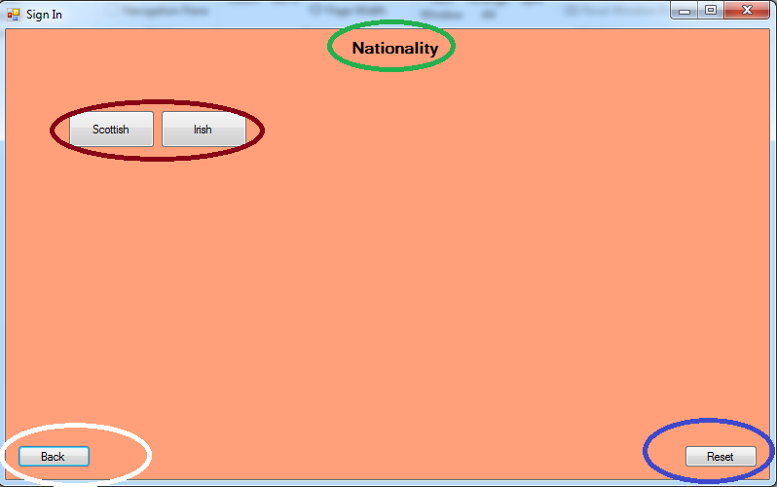

In case you make any errors during the selection process, the back button (circled in white) can be pressed to take you to the previous selection.

Next is the reset button, circled in blue, which performs the same task as the back button, but instead of returning one step, it goes back to the start.

The Text circled in green is what you must choose from the boxes below. This changes along with the question being asked and the choices available.

In red are the choices available to the patient. Clicking one will go to the next question.

1. **The Confirmation Screen**

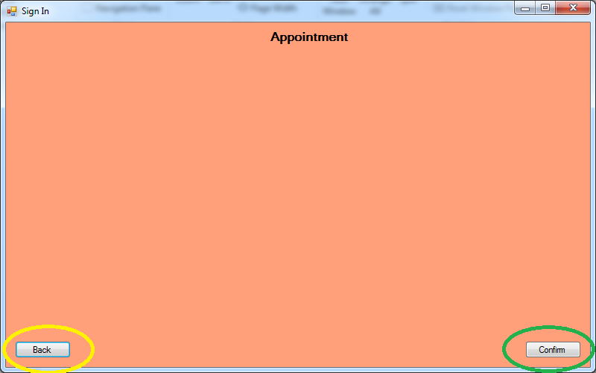

Once you have reached this screen, it is time to either go back of confirm that you have chosen the correct appointment. If you are happy with the details you have picked, click the confirm button in green. Otherwise, click the back button circle in yellow and alter your choices.

1. **The Attendance Confirmation Screen**

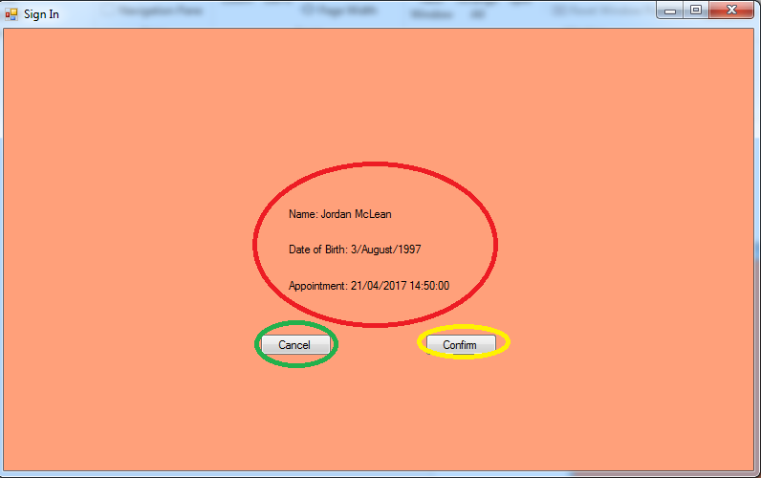

Things to be aware of here are the details in red. If these details are incorrect, have a look to double check if they are correct and the appointment time is accurate.

The Cancel button should be clicked it you are unhappy with the results, and the process should be restarted.

If you are happy with your results, you should click the confirm button in yellow. This will confirm to the administrators that you are in attendance.

# Doctor’s Guide

1. **Signing In**

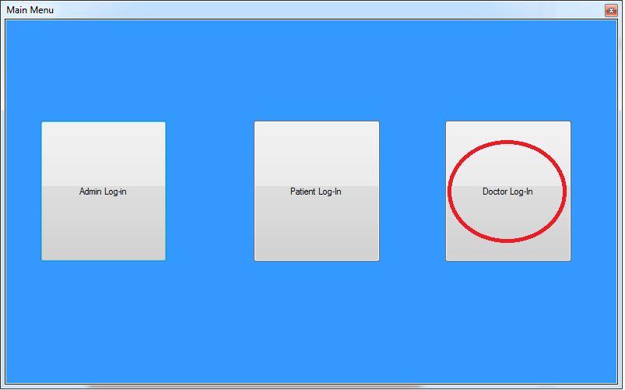

To Sign in to your doctors account, you are going to want to click the button on the right to open the log-in interface. Once you are here, you must enter your credentials which are case sensitive. Once entered, click the “Log-in” button and you should be taken to the next screen.

1. **Doctor’s Home Screen**

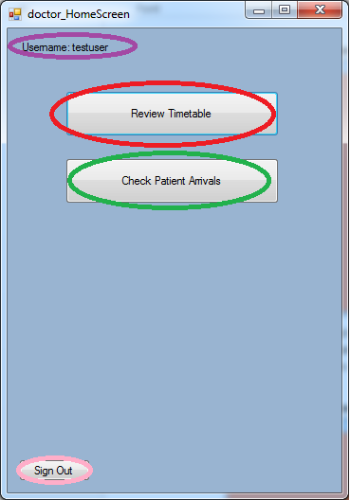

The Doctor’s Home screen consists of all of the functions available to you as a Doctor. You can also see your username located at the top, circled in purple.

You can check whether or not a patient has arrived in “Check Patient Arrivals”, which is circled in green and is accessed by clicking the button.

You can check your timetable for the week in the “Review Timetable, which is circled in green and can be accessed by clicking the button.

Once you are finished whatever business you had on your account, make sure to sign out of your account and return to the main menu by clicking the “Sign out” button, which is labelled in pink.

1. **Reviewing the Timetable**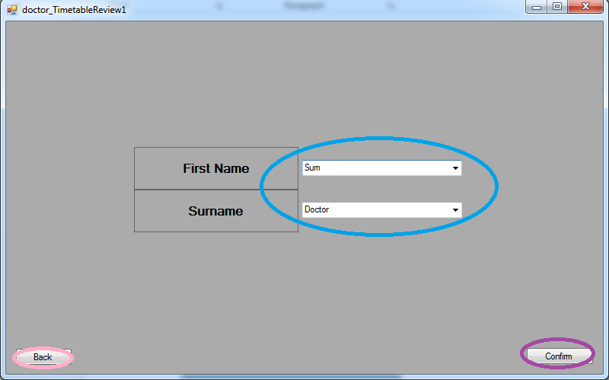

In the review timetable screen, you must first pick whose timetable it is that you want to view. This is because your account is not dedicated to any single doctor, and it would also be a useful function to see what other staff are working.

Once you have selected from the drop down menu whose timetable you want to view, you should click the “Confirm” button to go to the next screen.

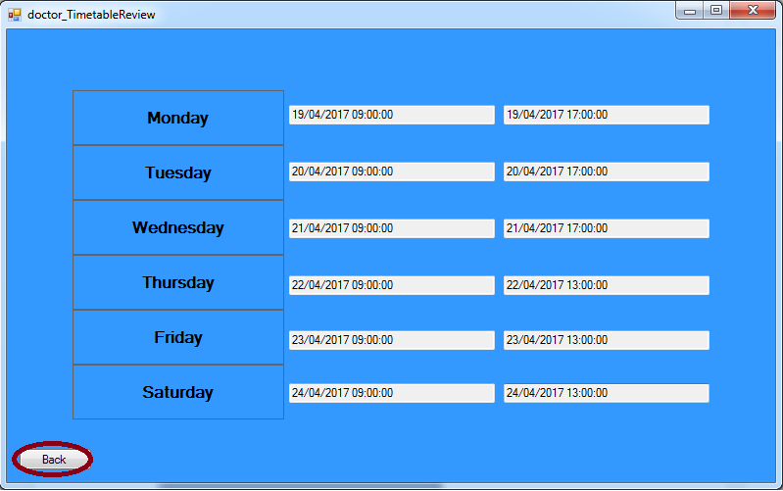

Once you have clicked “Confirm”, you will see this screen, showing you the starting and finishing times from Monday to Saturday for the staff member you have chosen.

If you are happy with what you have seen, click the “Back” button to return to the previous screen. If you don’t wish to view any more staff members, click back again. If you do, simply change the name chosen in the drop down box and confirm again.

1. **Checking Patient Arrivals**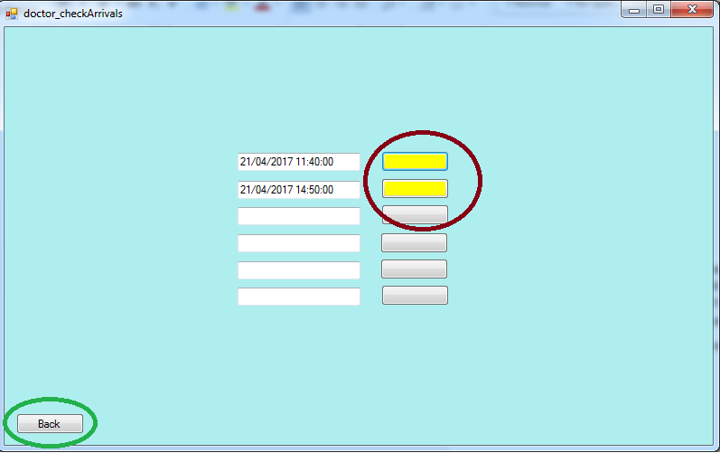

In the Check Patient Arrivals screen, you are greeted by the next 6 appointments in the day. A colour code is in place with green meaning the patient has arrived, yellow meaning they are yet to arrive. If there are any cancellations, the appointment will simply cease to exist on the arrival list.

If you are satisfied with this information, simply click “Back” to return to the home screen.

# Administrator’s Guide

1. **Signing In**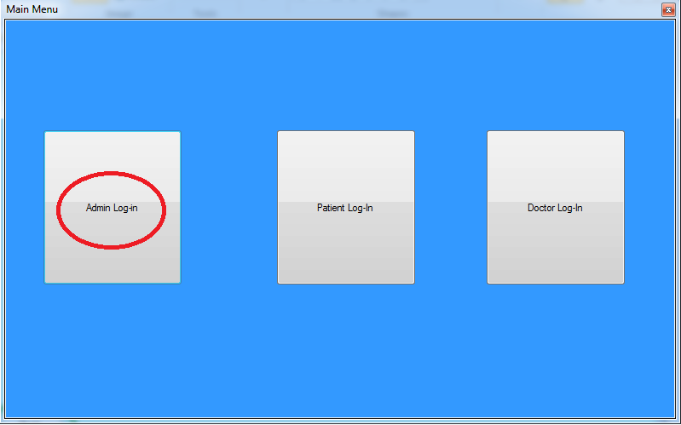

To Sign in to your admin account, you are going to want to click the button on the left to open the log-in interface. Once you are here, you must enter your credentials which are case sensitive. Once entered, click the “Log-in” button and you should be taken to the next screen.

1. **The Administrators Home Screen** 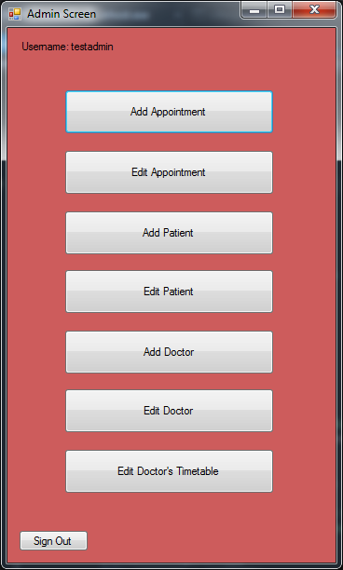

On this screen you will be greeted by a number of options, your username and a sign out option for when you are finished.

From this screen you may choose to add an appointment, edit an appointment, add a new patient to the database, edit a patient from the database, add a new doctor or edit a pre-existing doctor. You also have access to the Doctor’s timetable, which you can edit start and finishing times for each day.

1. **Adding an Appointment** 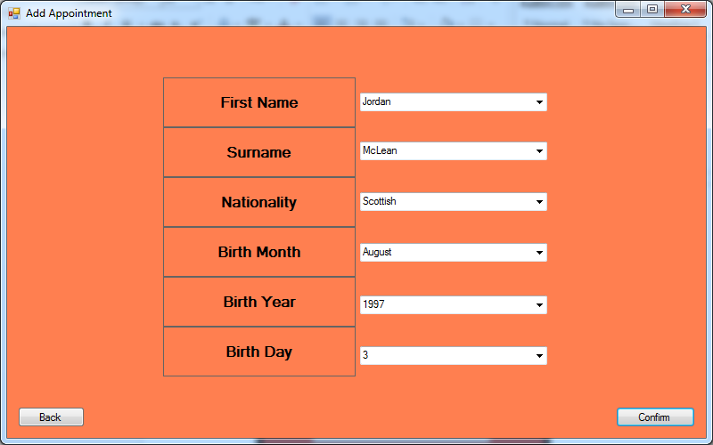

To add an appointment you must first choose from the drop down menu which patient it is that you are trying to schedule an appointment for. Once you have done this, you should click the “confirm” button to head to the next screen. If you wish to return to the home screen, simply click “Back”.

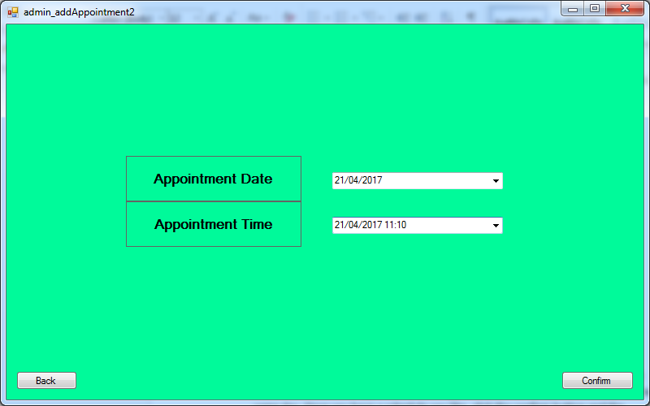

From here you can choose which time, between 09:00 and 17:00 hours you would like to schedule the appointment for. Appointments can only be scheduled for the same day. Once you have a schedule you like, click the confirm button and the appointment will be created in the database. Should you change your mind or have selected the wrong patient, simply click “Back”.

1. **Editing an Appointment** 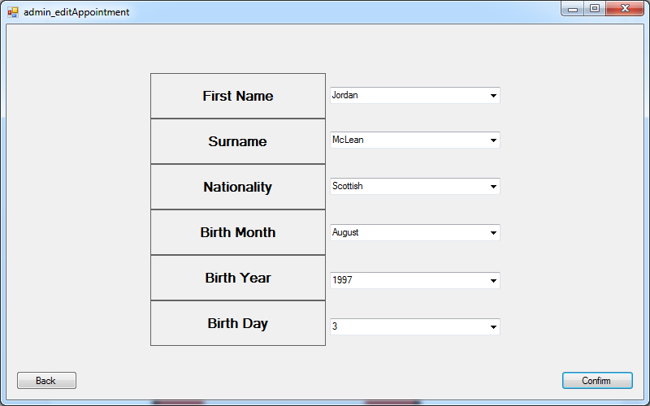

To edit an appointment you must first choose from the drop down menu which patient it is that you are trying to edit the appointment of. Once you have done this, you should click the “confirm” button to head to the next screen. If you wish to return to the home screen, simply click “Back”.

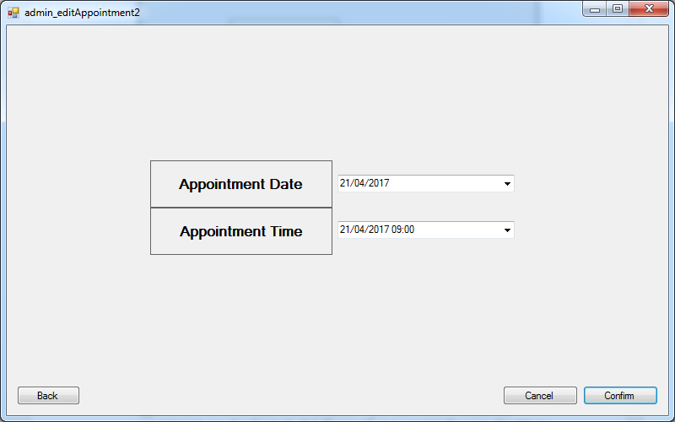

From here you can choose which time, between 09:00 and 17:00 hours you would like to reschedule the appointment for. Appointments can only be scheduled for the same day. Once you have a schedule you like, click the confirm button and the appointment will be created in the database. If you have come to delete the appointment, you should simply click “Cancel” upon opening the page. Should you change your mind or have selected the wrong patient, simply click “Back”.

1. **Adding a Patient** 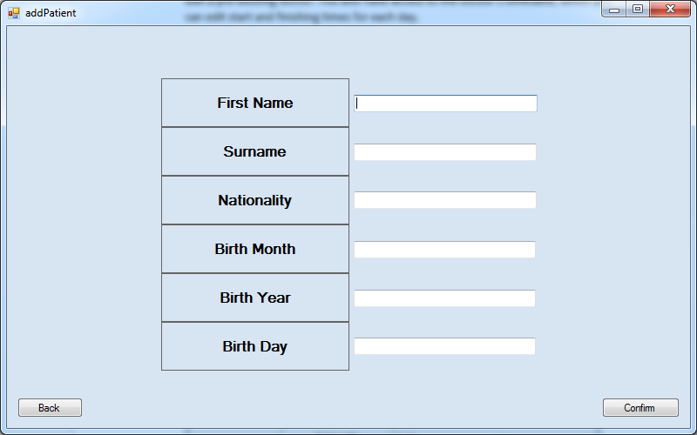

To add a new patient to the database, all you must do is fill in the text boxes with the details asked to the left. First Name in the text box to the right, etc. Once First Name, Surname, Nationality, Month of Birth, Day of Birth and Year of Birth have all been entered, simply click “Confirm” and the patient will now be added to the database. If you wish to return to the home screen without adding a patient, simply click “back”.

1. **Editing a Patient** 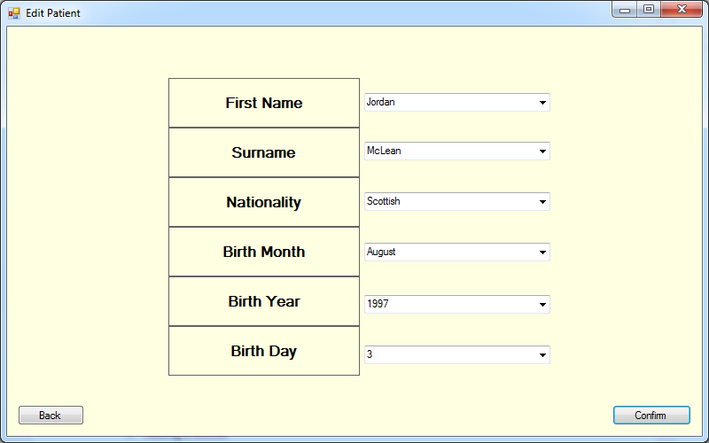

To edit a patient’s details you must first choose from the drop down menu which patient it is that you are trying to edit the details of. Once you have done this, you should click the “confirm” button to head to the next screen. If you wish to return to the home screen, simply click “Back”. 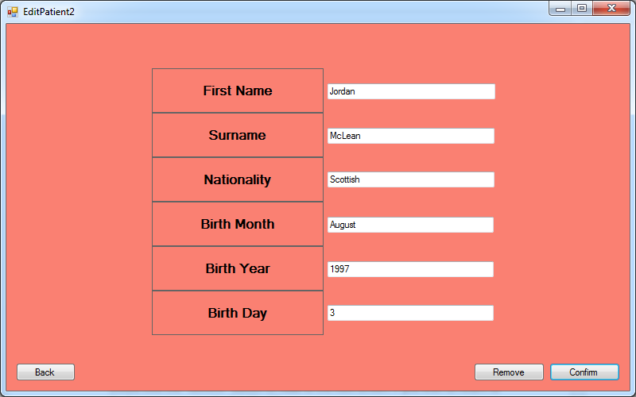

To update a patient from the database, all you must do is fill in the text boxes with the details asked to the left, deleting the old value and replacing it with the new. First Name in the text box to the right, etc. Once First Name, Surname, Nationality, Month of Birth, Day of Birth and Year of Birth have all been entered, simply click “Confirm” and the patient will now be added to the database.

To delete the record of the patient, you must simply click “Remove” and the record will be cleared from the database.

If you wish to return to the home screen without editing a patient, simply click “back”.

1. **Adding a Doctor** 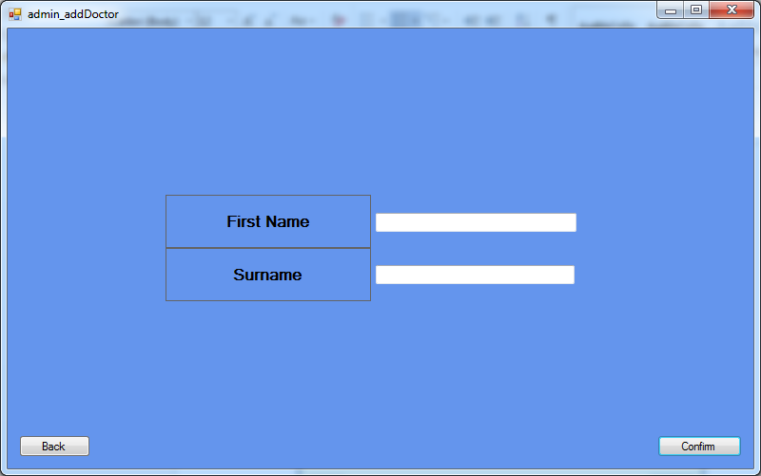

To add a new doctor to the database, all you must do is fill in the text boxes with the details asked to the left. First Name in the text box to the right, etc. Once First Name and Last Name have been entered, simply click “Confirm” and the doctor will now be added to the database. If you wish to return to the home screen without adding a doctor, simply click “back”.

1. **Editing a Doctor** 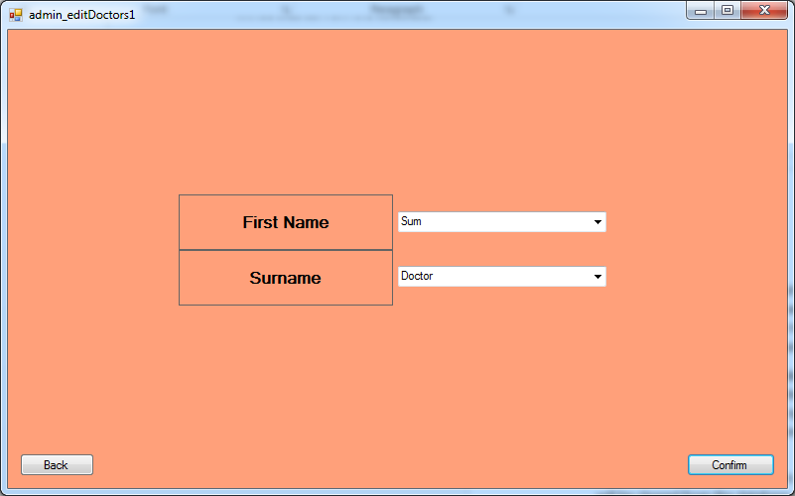

To edit a doctor’s details you must first choose from the drop down menu which doctor it is that you are trying to edit the details of. Once you have done this, you should click the “confirm” button to head to the next screen. If you wish to return to the home screen, simply click “Back”. 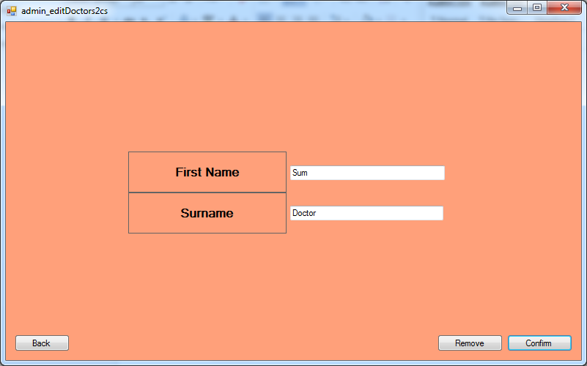

To update a doctor from the database, all you must do is fill in the text boxes with the details asked to the left, deleting the old value and replacing it with the new. First Name in the text box to the right, etc. Once First Name and Last Name have been entered, simply click “Confirm” and the doctor will now be added to the database.

To delete the record of the doctor, you must simply click “Remove” and the record will be cleared from the database.

If you wish to return to the home screen without editing a doctor, simply click “back”.

1. **Editing the Timetable of a Doctor** 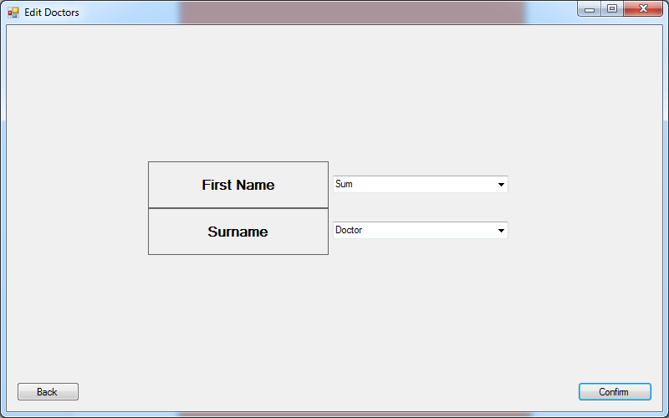

To edit a doctor’s timetable you must first choose from the drop down menu which doctor it is that you are trying to edit the timetable of. Once you have done this, you should click the “confirm” button to head to the next screen. If you wish to return to the home screen, simply click “Back”.

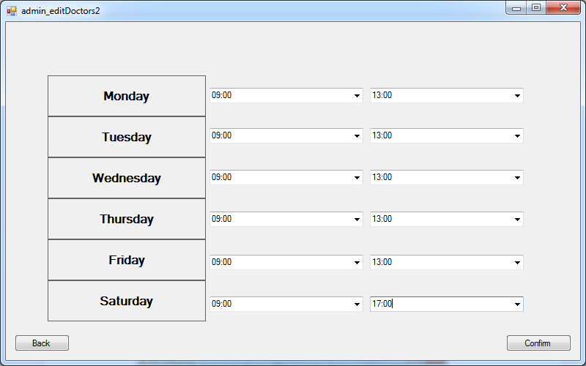

To set the timetable of the doctor for the week ahead, all you must do is choose the starting time and finishing time from the drop down box for each day of the week. You will not be allowed to exceed a max number of working hours (37) and will be warned if you do. If you are happy with the schedule, you should click the “Confirm” button to save the timetable to the database.

If you wish to return to the home screen without altering the timetable, you should click the “Back” button.